Software Screenshots:

Packing Supplies

| july-20 |

**Document Overview**

**Documentation Goals**

This documentation is intended to provide instruction for ***(XYZ – REPLACE WITH DOC Function)****.*

**Documentation Disclaimers**

* Teach a user how to utilize or develop in Progress.
* Provide instructions for creating or administering and Advantzware Progress Database.
* Provide application Support for other Advantzware functions.

**Special Terminology**

* ***REPLACE/LIST any special terminology for the document***

**Table of Contents**

**[Heading 1]** 3

[Heading2] 3

[Heading3] 3

# **Overview of Advantzware Specific Keys and Icons**

## Function Keys

|  |  |
| --- | --- |
| BRWS | The browser, which is a list of records in this file. This is functionally equivalent to the Find option of our standard package. |
| VIEW | View record provides the ability to ADD, CHANGE, DELETE, and UPDATE an individual record. |
| SORT BY | The selections at the bottom of the browser, which will sort the list alphabetic order. |
|  |  |
| Update | Update the current record. |
| Reset | Reset the current record. |
| Add | Add a record. |
| Copy | This will copy the existing record. |
| Delete | Delete the current record displayed on the screen. |
| Cancel | Cancel the information that was entered. |
| Save | Save the record. |
|  |  |
|  | Takes the user to the first current record. |
|  | Moves backward one record. |
|  | Moves forward one record. |
|  | Takes the user to the last current record. |
|  |  |
| F1 | Miscellaneous Fields |
| F3 | Search |
| F3 | List |
| F4 | Notes |
| F6 | Browse |
| F7 | Viewer |
| F12 | Exit |

## Advanced Software Standard Function Keys

|  |  |
| --- | --- |
| Next | Shows the next sequential record. |
| Prev | Shows the previous record. |
| Add | Add a record. |
| Change | Change the current record displayed on the screen. |
| Delete | Delete the current record displayed on the screen. |
| Find | Find a record by searching by description. |
| “1”, “2” | Number 1 or 2 to go the first or second page of this record. |
| Esc | Escape from the current transaction without updating. |
| Q | Quit from the current transaction without updating. |
| F1 | Save |
| F3 | Help information is available on every data field. Simply place the cursor on a field and press F3 to display documentation regarding this particular field. |
| F3 | To insert additional data in a data field without erasing the information currently displayed. |
| F4 | Notes – General |
| F1 | Field Lookup is available on every data field which is maintained in a separate file. Place the cursor on a field and press ***“F1”*** to search for the code by description or to advance a screen of records by pressing the next key. Place the cursor next to the desired record and press enter to transfer the record to the data entry screen. See ***“Page Up”*** / ***“Page Down”*** keys below as an alternative |
| F7 | Delete |
| F8 | Notes – File Specific |
| Enter | Advances the cursor to the next field |
| Page Up | Will skim forward through each record in a data file in sequential order |
| Page Down | Will skim backward through each record in a data file in sequential order |
|  |  |

## Program Icons

|  |  |  |
| --- | --- | --- |
|  | Job Notes |  |
|  | Customer Attachments | Attach files (such as Word/Excel/Images) for this specific customer order. |
|  | Change Move/Set Column Mode |  |
|  | Print Acknowledgement |  |
|  | Export to Excel |  |
|  | Add |  |
|  | Attachments | Attachments for this Estimate. Will transfer to all future repeat orders for this estimate. |
|  | Notes |  |
|  | Spec Notes | Notes for specific finished goods items. |
|  | Utility Application |  |
|  | Help |  |
|  | UDF Viewer |  |
|  | Commissions |  |
|  | Exit |  |
|  |  |  |
|  |  |  |

# **Cost Estimating / Farm Outs**

Just one letter automates the distribution logic in the estimating program. Most distributors of packaging also buy and manufacture packaging materials such as boxes, folding cartons, foam, displays and partitions. Advantzware handles the manufacturing or buy/sell fast and easy.

Many box plants that resell packaging supplies do not want the end user to know that they are buying the product. The best way to hide this fact is to create a quote with the same specifications as a converting plant. The Advantzware P/M for purchased / manufacturer field automatically sets the estimate as a BUY/ SELL order. This includes a FARM folder that houses unlimited vendor costs for the product.

The ***“P”*** field also sets the costs equal to zero for glue, ink and imports a farmout machine to the routing with zero cost. This allows the sales representative, customer service department or estimator to enter all the needed specifications such as box size, board grade, colors, unitization details and any other manufacturing requirements. This data can then be printed on the quote and will also be transferred to the box plants purchase order so that the vendor will produce the item to the correct specifications.

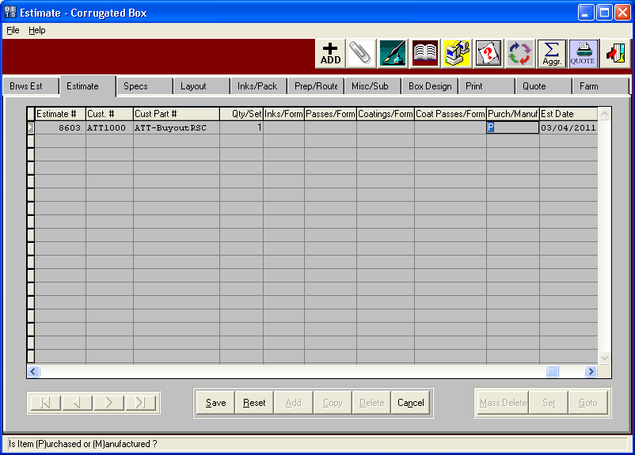

Vendor costs are easily stored for purchased boxes, die cuts, foam, folding cartons, point of purchase displays or assembled partitions. The FARM folder allows defining the quoted cost for each requested quote quantity. The program also tracks the setup charges by quantity and the minimum and maximum sheet sizes that each vendor can manufacture. The programs pick the best cost for each quote quantity for transfer to the quote history file.

Once an order is placed for this customer part, the Advantzware order entry program will create a sequentially numbered finished goods item code and transfer the estimates FARM folder costs to the box plant inventory item, which will transfer to the purchase order to the vendor. Depending on system setup parameters, the system will check reorder levels and prompt to create the vendor purchase order during the order entry process.

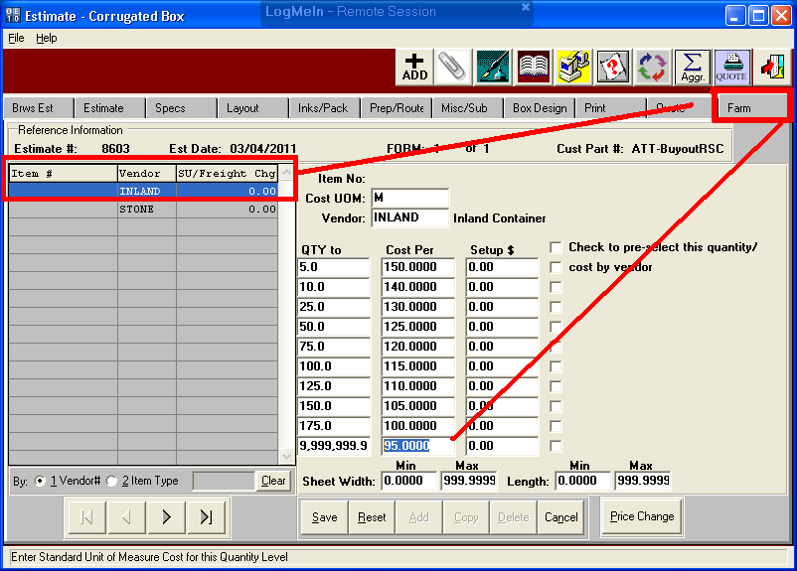

# **Customer Quotes**

The PRINT folder calculates each quantity sell price based on the best cost from each vendor’s cost matrix. The WHATIF button allows the sales manager to change gross profits, net profits or margins to determine the sell price. Of course, changing the sell price to match a competitor will recalculate margins, commissions and profit percentages. Once the sales price is set, this information is transferred to quote history for future analysis.

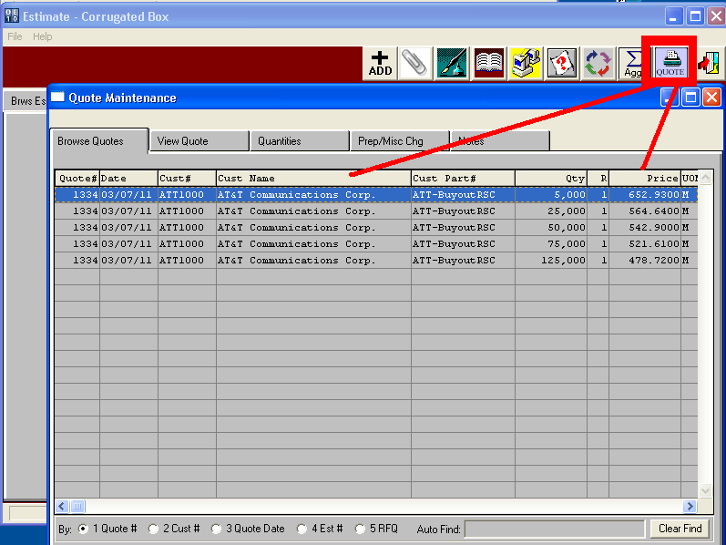

The quote file houses the data to print or email the quote from complete with you company logo. The email will be sent directly to contract names defined on a distribution list for these customers, simply by clicking the QUOTE and email buttons.

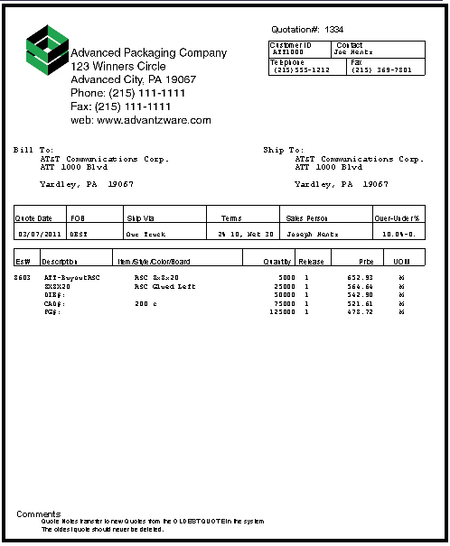

# **Customer Price Sheet**

The quote history file can also produce a price list of purchased items. The plus sign allows adding a quote from the customers part history. The box plant can select from the entire list of manufactured and purchased items sold to the customer. This price sheet created provides the customer a reorder sheet.

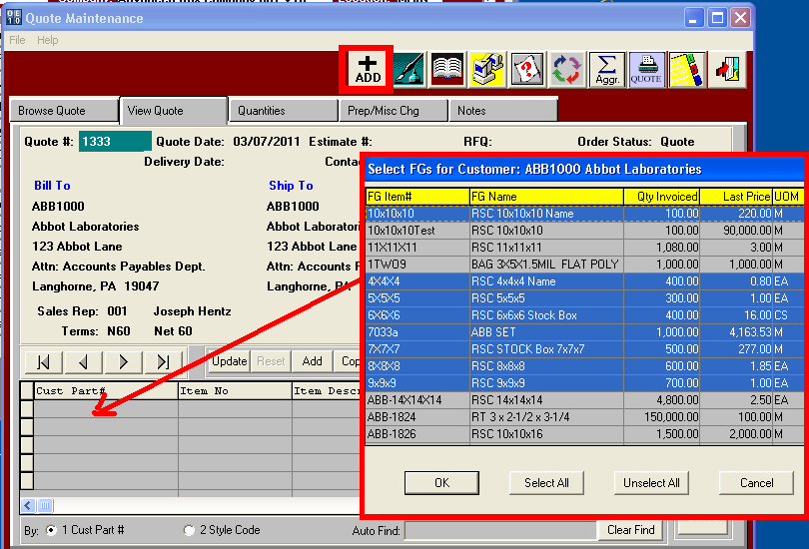

Only the items selected will print on the customer price sheet. This is a good business form to email to the customer, so they know what items they buy from your company and what the on-hand balance for each item. The price sheet provides the customer a reorder sheet so they can simply enter an order quantity and fax or email back to your sales department.

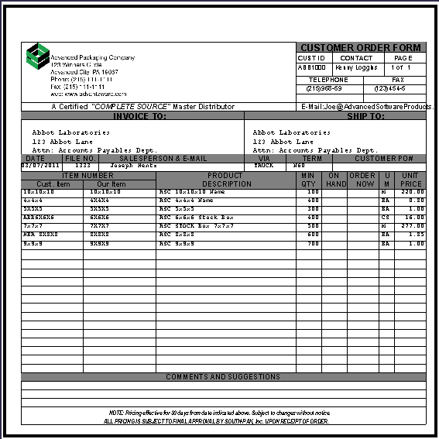

# **Order Processing – Order Entry**

This screen shows the power of Advantzware’s ability to combine a variety of finished goods types. Orders may be downloaded electronically via web orders from your website attached to ASI ANYWARE or manually typed by customer service. Orders for custom jobs, farm out items and packaging supplies can be added to a single customer order. This saves data entry time as one order, on order acknowledge and even one bill of lading can be created from this single order.

The program is smart enough to create a job for custom boxes and to prompt to create purchase orders for purchased items such as farm outs and packaging supplies. Customer service types an estimate number for custom jobs or farmouts or leaves this field blank to search for a packaging goods stock items. Customer service presses the ***“+”*** Sign or ***“Add”*** button to add a customer order then bypasses the estimate number to add orders for packaging goods and stock items.

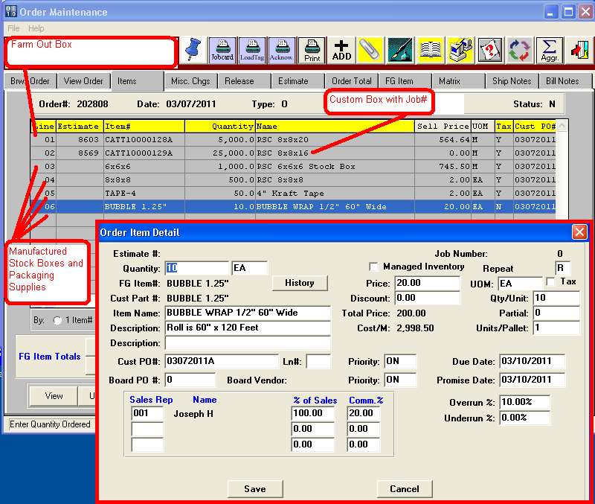

# **Order Processing – Price Matrix for Customer Pricing**

The Price Matrix houses unique prices for each finished goods item. This example shows unique pricing for an 8x8x8 for customers IBM, ATT and ABC which have sell prices per Each. This screen also shows that all customer defined as a customer type equal to brokers will have unique pricing per thousand starting at $1,050 per thousand for the smallest quantity.

The price matrix listed with no customer and no customer type will be used for all other customers including counter sales and walk in customers. The detail price matrix for customer ATT1000 can house 10 unique selling prices for each quantity break. Alternatively, the matrix can be set to provide a discount off list price from the inventory file.

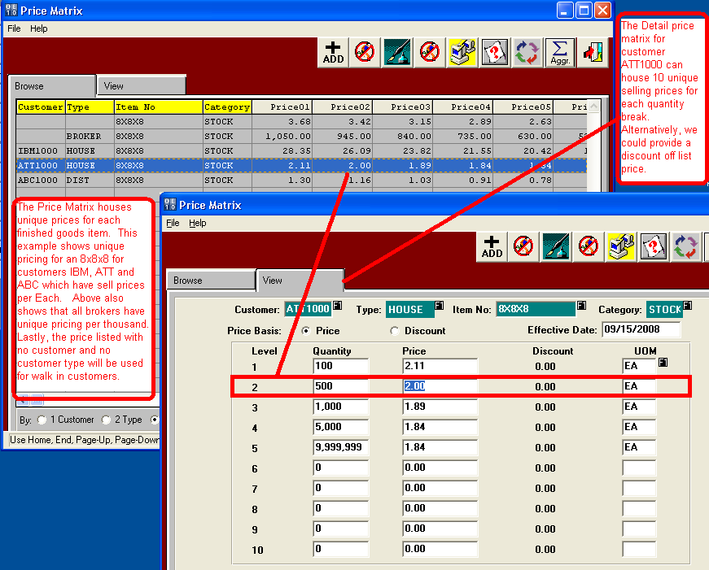

# **Order Processing – Adding Items from Sales History**

Another unique feature of order entry is to choose an item from past sales. The HISTORY button shows all the previous sales to the customer on the order. Double click on any item will show the previous invoiced price. If the customer service selects this item, the price and item will transfer to the order entry screen.

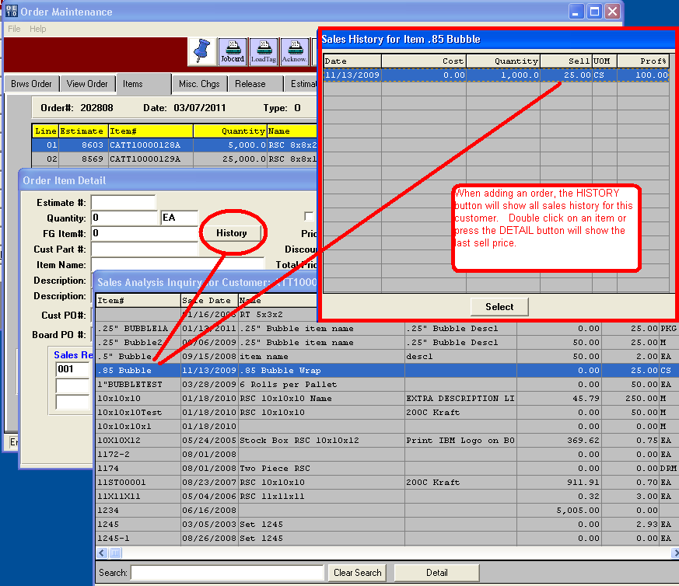

# **Order Processing – Adding Orders for Purchased Custom Boxes**

The estimate 8603 is for a purchased farm out box so the program knows to prompt to create a purchase order for the finished goods item. Please note, the program automatically creates a very well-organized item code complete with the item master record with all manufacturing specs and inventory on order and allocated quantities updated.

The system displays the best cost vendor to place purchase order and also asks if this is a drop shipment so your vendor can deliver directly to your customer. Advantzware also saves many hours processing drop-shipments while keeping tight inventory control.

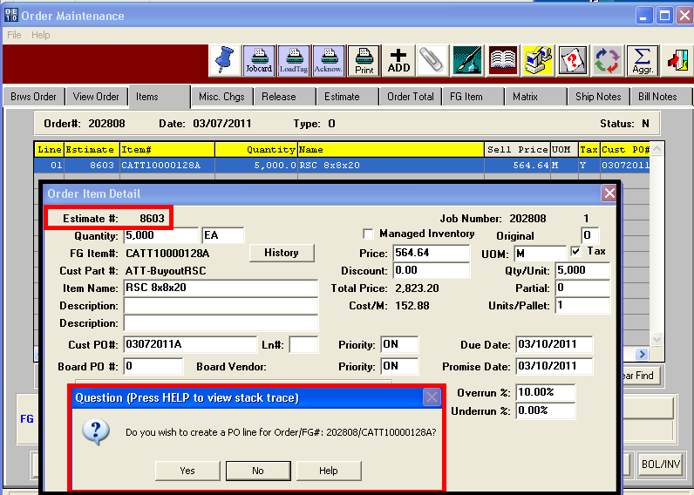

# **Order Processing – Adding Order & Jobs for Custom Boxes**

The estimate 8569 is for a manufactured custom box so the program knows to prompt to create a job to produce the item but also creates a purchase order for the raw material board material. The program creates a very well-organized item code consisting of the product category code – C for customer box, the customer code ATT1000, a sequential part number specific to this customer and a revision code letter A.

Advantzware sets the item master record with all manufacturing specs such as die number, plate number, colors, blank size and vendor costs. In addition, the inventory balances such as job quantity on order and customer allocated quantities are updated.

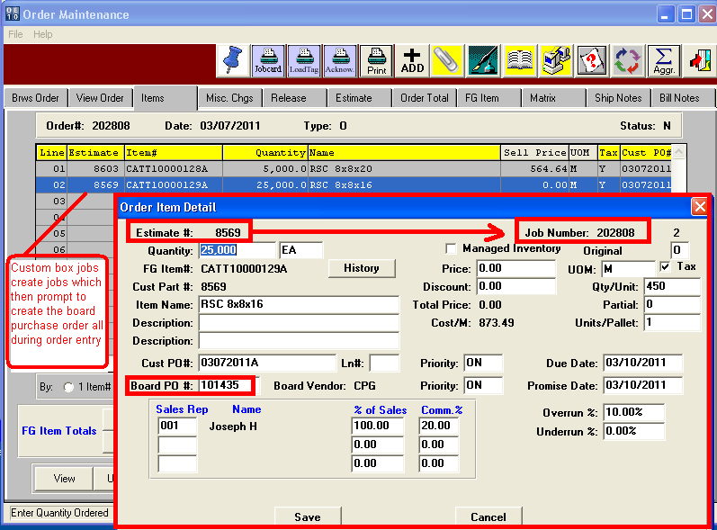

# **Order Processing – Release / Delivery Dates**

The Advantzware order entry software serves as a blanket ordering system that allows unlimited deliveries for any or all items on the order. Each delivery may have a unique ship location, ship quantity, delivery date, shipping instructions and a unique customer purchase order code. This saves countless hours keeping all the deliveries on a single customer order versus creating a separate order for each delivery.

Normally, shipping automatically creates the invoice based on the quantity delivered on the bill of lading. However, the release process allows shipping goods on consignment without invoicing, known as ship-only releases. Alternatively, an item may be warehoused for a customer for a contracted period of months. Once that time expires, the release status changes to an ***“I”*** (Invoice) status prompting for billing.

However, if the customer has limited warehouse space, we can create an invoice only delivery without shipping the goods. Advantzware will provide inventory reports for customer owned inventory that has not shipped.

Please Note: The quantity allocated can be set to update only once a customer has confirmed a delivery date. In this example, the customer ordered 25,000 boxes and has requested five separate deliveries, however only one has be releases.

This tight inventory control will prevent placing orders to replenish inventory as the available quantity is only updated from actual allocated.

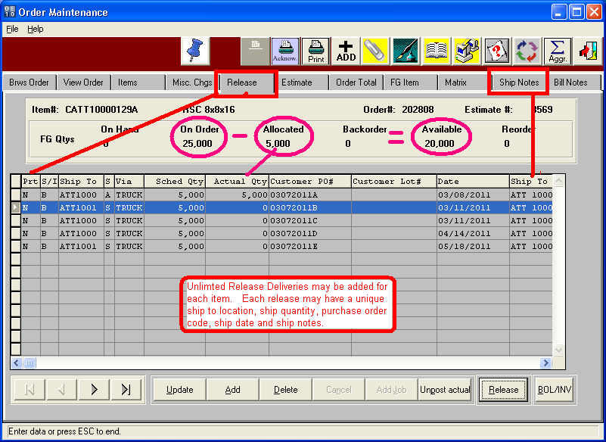

# **Inventory Receipts for Drop Shipments**

Orders for packaging supplies and purchased custom boxes may be shipped directly to the customer. Most vendors have the ability to ship the goods with the box plants bill of lading and logo. Drop shipments save time and money by saving delivery costs and materials handling charges.

However, inventory control must still be maintained by the box plant. Advantzware has a drop shipment feature that processes the inventory receipt, release, shipment and invoice all in once step. Once the vendor notifies you that the finished goods have been shipped to your customer, a simple receipt is all that is needed.

